Travel information

Accommodation information:
Address: Eastside Halls of Residence, Imperial College, South Kensington Campus, Prince's Gardens, London SW7 1AZ
Nearest tube stations: South Kensington, Gloucester Road
Campus map:
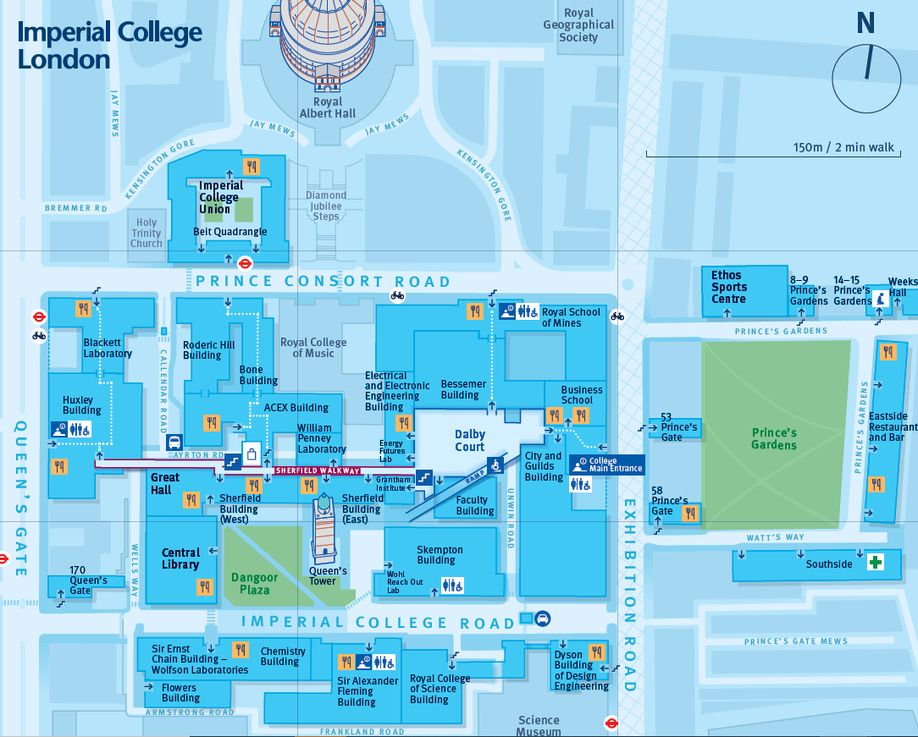
Eastside can be seen to the right of Prince’s gardens!

Exhibition information:
Address: 6-9 Carlton House Terrace, London, SW1Y 5AG
Nearest tube stations: Picadilly circus, Leicester Square, Charing Cross, Westminster
Routes from Eastside:
- Bus: Number 9 bus from Prince of Wales Gate (Stop RM) to Trafalgar Square Stop
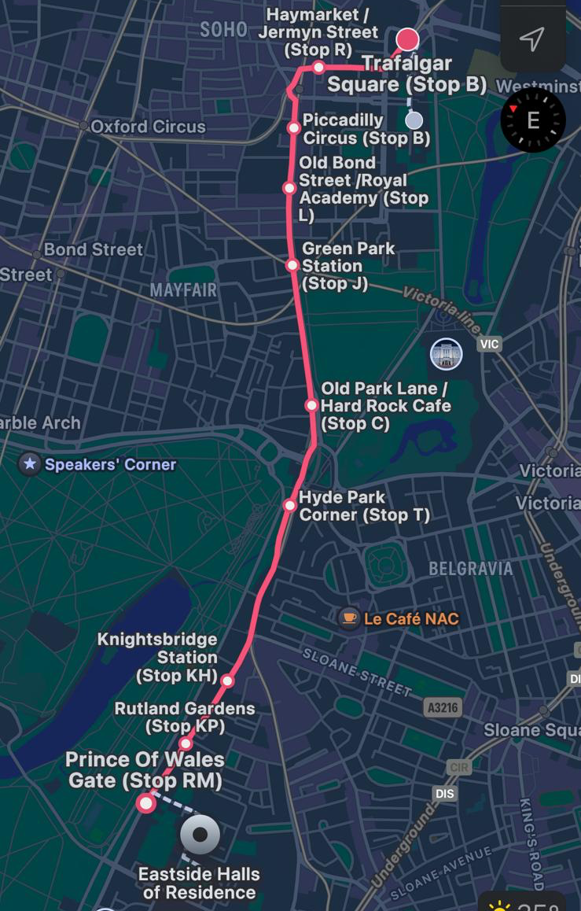
- Tube: Picadilly line from South Kensington station to Picadilly Circus station
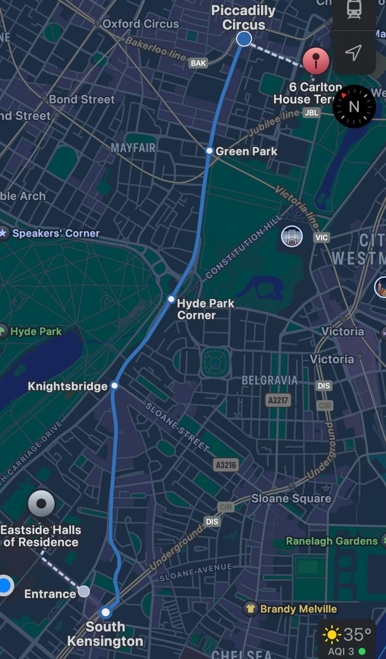
Additional information about travel can be found on the royal society website:
https://royalsociety.org/science-events-and-lectures/summer-science-exhibition/plan-your-visit/

