Leo Cancer Care

‘Evette’

R&D Immobilisation

Research Rig Manual

1. Safety and Regulatory Compliance
- Read first: Complete the laboratory equipment orientation before configuring or operating this research rig.
- Crush hazard: Keep hands, clothing, and cables clear of the moving seat and linear actuator.
- Weight limit: Do not exceed the maximum dynamic load rating 150kg
- Electrical safety: Ensure the power cord is routed safely to prevent tripping and cord damage.
- Participant safety: Never leave a test subject unattended while they are in the perched seating position.

2. Technical Specifications
Parameter | Operating Specification
Input Voltage | 220 - 240V AC, 50/60 Hz (24V DC Internal)
Actuator Stroke Range | 400mm (~16inches)
Max Lift Capacity | 2000N (450lbs) static force
Total Rig Weight | 75kg (165lbs)

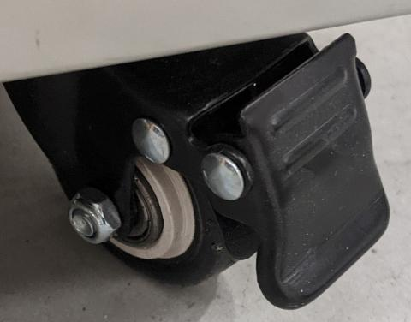
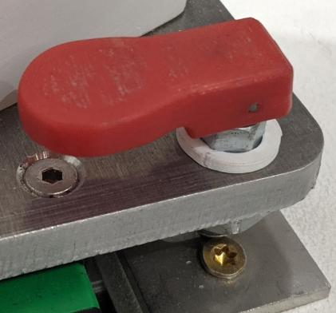
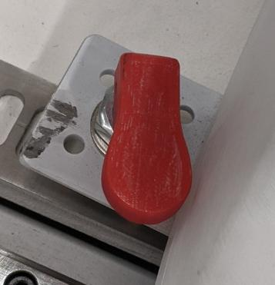
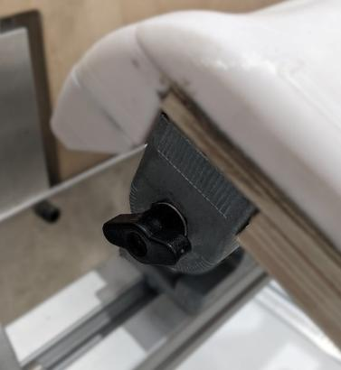
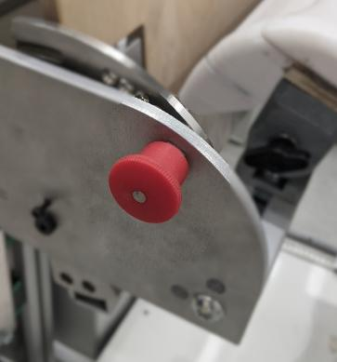
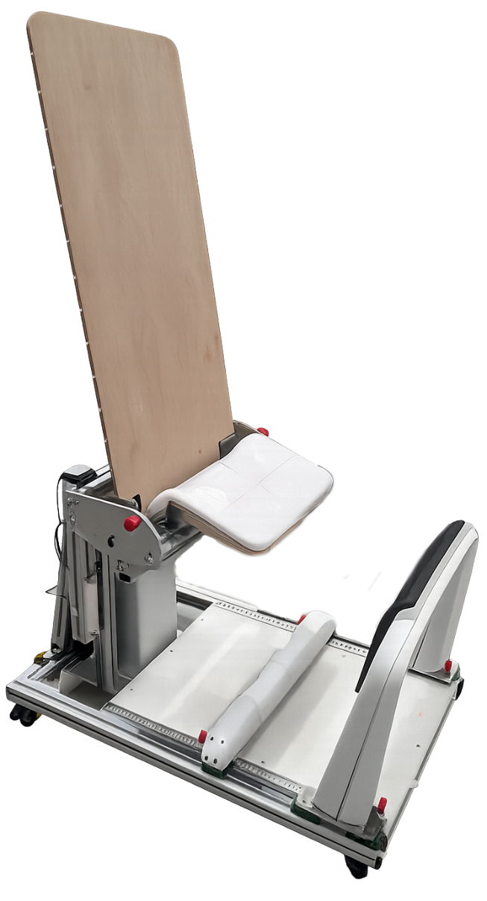
Back Rest Angle Locks (x2)
Seat Angle Locks (x2)
Shin Rest Locks (x2)
Wheel Locks (x4)
Heel Rest Locks (x2)
3. Pre-Operation Setup
- Placement: Position the rig on a flat, level, non-slip laboratory floor surface, and lock all 4 wheels.
- Power connection: Plug the 24V transformer into a grounded wall socket.
- Cable routing: Verify that the actuator cable has enough slack to move through its full range.
- Lock check: Ensure all manual adjustment quick-release pins and knobs are fully engaged.
- Clearance: Maintain a minimum 20cm perimeter of clear space around the seat when raising and lowering.

4. Standard Operating Procedure (SOP)
Assembly
- Orientate Back Rest: Hold the back rest upright so the pins are pointing vertically down.
- Locate Back Rest: Lift the back rest and position the pins over the interface.
- Attach Back Rest: Allow the backrest to drop into the holes and ensure it is fully home by pulling down on it.

Adjusting Seat Angle
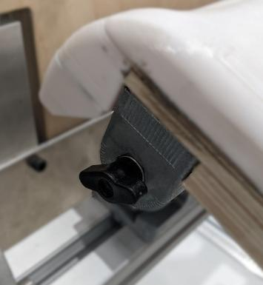
- Check current angle: Ideal angle is 45 or 60 degrees for perched seating.
- Loosen Clamps: Locate the black wingknobs either side of the seat and unscrew them.
- Rotate Seat: Holding the front of the seat, manually rotate about its axis to desired angle.
- Set angle: Screw black wingknobs tight on both sides of the seat.

Adjusting Seat Height
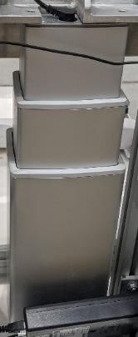 | 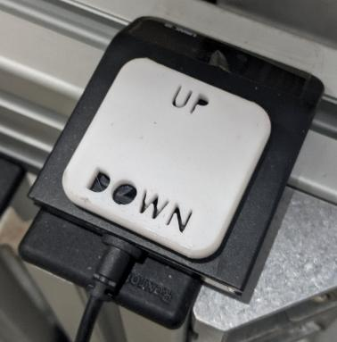

- Clear path: Verify no objects are underneath the seat assembly.
- Raise seat: Press and hold the UP button on the hand controller to lift.
- Lower seat: Press and hold the DOWN button on the hand controller to lower.
- Target height: Align the seat with the participant’s hip crease for an optimal perch baseline.
Setting the Shin and Heel Support
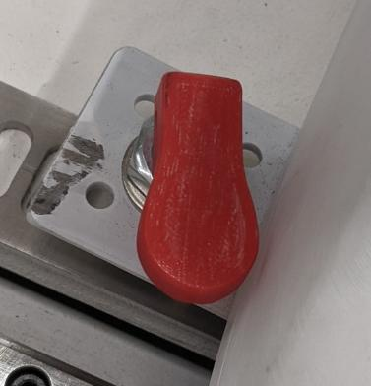

- Start Position: Ensure Shin Rest is moved away from the seat, and the Heel Rest tucked under the seat, with sufficient space for subject to enter.
- Position shin rest: With the locks disengaged, slide the padded shin rest toward the participant to match their tibia angle. Engage locks
- Position Heel Rest: With the locks disengaged, slide the Heel Rest toward the participant to prevent their feet moving backward. Engage locks
Setting the Back Rest Angle
- Release: Pull red handled pins straight out whilst keeping a hold on the back rest.
- Lock Out: Twist red handled pins to lock them out, to allow free movement of the backrest.
- Move: Orientate backrest to desired angle.
- Reengage: Twist red handled pins to allow reengagement
- Ensure Lock: Gently movement backrest forwards and backwards to ensure both pins fully lock in.
Participant Ingress
- Step in: Instruct the participant to stand on the rig, facing away from the seat.
- Place feet: Have the participant guide their heels securely into the lower heel cups.
- Rest shins: Instruct the participant to lean forward slightly until their shins rest against the foam pads.
- Perch: Lower or raise the seat until the participant is supported in the target semi-standing posture.
- Exit: To exit, have the participant step forward off the heel rests before raising the seat fully.
Participant Egress
- Prepare Participant: Instruct the participant that you are about to move the Shin Rest away.
- Move Shin Rest: Have the participant stand and step forward as you disengage the locks and move the Shin to the front of the rig.
- Exit: To exit, have the participant step forward away from the heel rests and down onto the floor.
5. Maintenance and Calibration
- After each participant: Wipe the seat, with antibacterial wet wipes. Wipe Shin Rests if the participant had bare legs.
- Prior to study commencement:
- Check function of:
  - Linear Actuator,
  - Shin Rest locks,
  - Heel Rest Locks,
  - Seat Angle Locks
  - Wheel Locks.
- Clean and apply thin oil to Linear Slides
Disassembly
- Electrics: Ensure unplugged and no loose or dangling cables can get caught.
- Heel Rest: Move fully under the seat and lock.
- Shin Rest: Move away from the seat and lock.
- Back Rest: Remove Back Rest and place on top of the unit.
6. Troubleshooting
- Actuator will not move: Check that the unit is connected to the mains and all cable plugs are seated deep.
- Intermittent movement: Inspect the hand controller cable for pinches, cuts, or internal wire strain.
- Shin/heel support slips: Clean any oils or dust off the adjustment tracks and tighten the locking knobs.
- Squeaking noises: Apply silicone lubricant spray directly to the manual adjustment slides and hinges.

