Ad-hoc Meeting with WP2, WP3 & WP6 to discuss the Target Chamber, Nozzle & Gabor lens.
LhARA wiki location for documents related to this meeting: here
Present: Chris Baker, Neil Bliss, Nick Dover, Ross Gray, Clive Hill, William Shields, Colin Whyte.
Apologies: Ajit Kurup, Jaroslaw Pasternak, Ken Long.
Actions | Description | Status
23-04-20-01 | Ross to provide the new design of the tape drive being developed. | In progress
23-04-20-02 | Ross to provide details of the camera mirror arrangement. | In progress
23-04-20-03 | WP2 to provide details of the slide accuracy/repeatability specification.
Clive Hill presented slides document: 1272-pa1-meng-prs-0004-v2.0 Target Chamber 2023-04-20
Slide 2 showing the CAD model provided by Ross used on Gemini that has relevant components for the LhARA target chamber.
Action 23-04-20-01: Ross to provide the new design of the tape drive being developed.
Slide 3 shows the SCAPA set up CAD model supplied by Colin for reference.
Slide 4 & 5 show the LhARA target chamber configuration Option 1 with angle between the last 2 laser beam paths at 45°. To fit in the Camera, beam splitter and 20mm translation the dimension from the target to Nozzle exit is increased from 100mm to 150mm.
In this arrangement the OAP to target distance is 165mm F/1.5 as specified.
An in-vacuum vacuum valve (Slide 8) has been integrated into the nozzle that could be closed to allow venting of either side of the nozzle, while not impacting on the opposite of the nozzle. This valve is not available from a supplier as a standard device but would be a specially designed device to meet the requirements.
Additional components after the camera should be added to the CAD model.
Conclusions:
- 150mm is too long because the particle beam generated will diverge too much before focussing impact of the plasma.
- An estimate for the start of the plasma is ~ 80mm from the nozzle exit.
- The simulations by Will is currently set at 150mm.
- The camera and beam splitter arrangement are the components that dictate the increase from 100mm to 150mm dimension
- A smaller camera is not an option to be considered.
- Consider rotating the tape drive around by 180° about a vertical axis through the laser spot. This may require the wider tape drive.
- Several options can be considered to reduce the target to nozzle exit dimension from 150mm to 100mm
  - A small mirror (figure 1) could be implemented between the target and the camera to allow the camera assembly to be rotated.
Action 23-04-20-02: Ross to provide details of the camera mirror arrangement.
  - Nick suggested an option where the camera could be removed and a “Retro System” fitted. A retro system would give less accurate information on the focal spot than the current configuration. This may be an acceptable compromise, but is not a high priority for further analysis now. This option is on hold at the moment.
  - Move mirrors M3 & M4 (OAP), tape drive target and camera assembly on a precision slide to gain extra space between the target and the nozzle while setting up the laser focus on the target at low intensity. The slide must be very parallel and repeatable with the mirror M2 path.
Action 23-04-20-03: WP2 to provide details of the slide accuracy/repeatability specification.
Slide 6 & 7 show the LhARA target chamber configuration Option 2 with angle between the last 2 laser beam paths at 23.1°. The dimension from the target to Nozzle exit has also been increased from 100mm to 150mm.
In this arrangement the OAP to target distance is 210mm F/1.9 less laser intensity than specified.
Additional Conclusions to that listed in Option 1 conclusions:
- Option 2 at 23.1° is preferred over Option 1 at 45°.
- A horizontal beam path rather than vertical should be investigated.
- The angle between the laser beam and the target shown as 45° on both Options 1 and 2 is not fixed. Planned experiments will determine the optimum angle.
- A top hat arrangement for the nozzle protruding into the Gabor lens vacuum chamber could be considered.
- A top hat arrangement for the Gabor lens flange protruding into the target chamber could be considered.
- A smaller mirror mount can be considered for mirror M3.
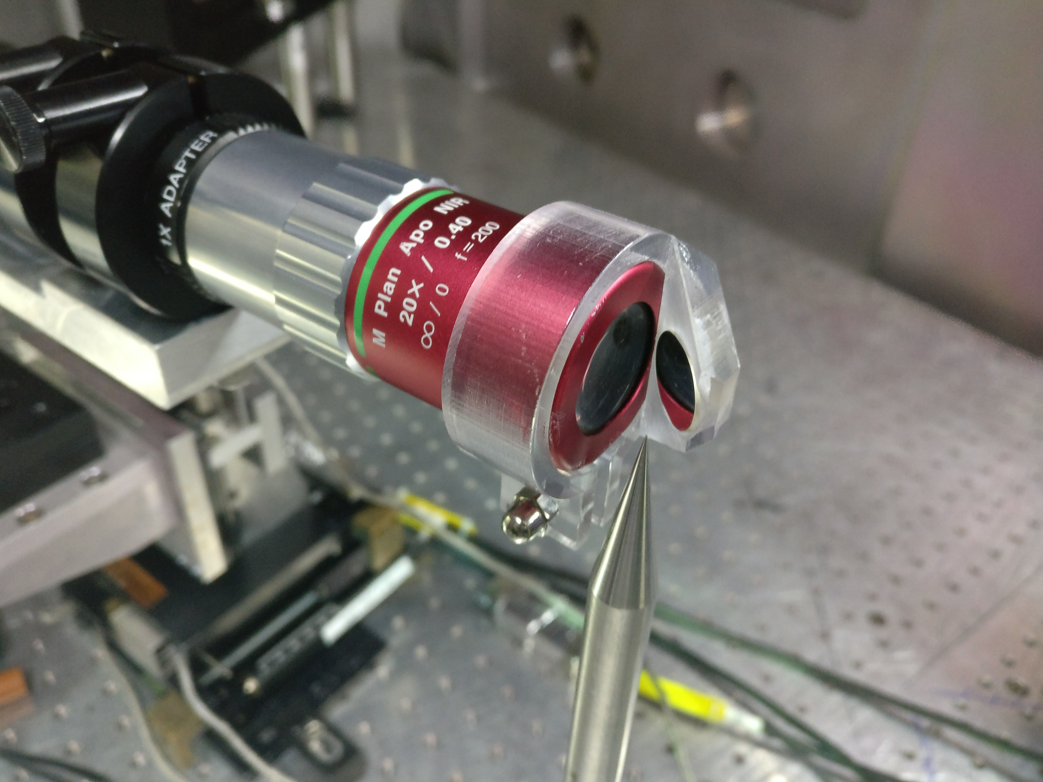
Figure 1: A small mirror could be implemented between the target and the camera.

Caveats:
- The design is a concept and to be considered preliminary.
- WP2 are yet to do their first LhARA dedicated experiment. There may be changes in the position of the diagnostics and a need for additional beams to reach the front surface of the target (for probing and conditioning the front surface) for example.
- If in the longer term we switch to using a waterjet target, the setup might look considerably different. The key is that we feed these changes back in a timely way to the concept design and others but the work of WP2 is to try to define the setup and conditions required to optimise the source, and this work is of course still in progress.
- WP2, WP3 & WP6 work needs to integrated, which can be by ad-hoc meetings at the moment to avoid adding extra meetings at this stage. If a more regular meeting is needed later that could be implemented later in the CDR stage.

Next meeting to be organised before IPAC in week 1 - 5th May.
Neil Bliss, 22nd April 2023.

