3.6 Instrumentation
The LhARA facility will be built in two stages. Stage 1 incorporates the laser-driven source, a capture system based on Gabor lenses and a 90 degree bend, using conventional magnets, and terminates at the first end station. Stage 2 uses a transfer line beginning before the bend in the Stage 1 layout, injecting the beam into a FFA for further acceleration to 127 MeV (for protons) and ending in the second end station.
It is therefore convenient to divide the beamline instrumentation into three parts: that required for the laser system, the low energy Stage 1 beamline and the high energy Stage 2 beamline. In addition to the instruments for the beamline itself, instruments for dosimetry of the final beam at the end stations are required.
Instrumentation for the RF system and vacuum system are considered under the relevant sections.
I am mainly thinking of a proton beam but note that there are some ideas on ion instrumentation in the CLF presentation [REF_Brenner].
3.6.1 Laser system
It is proposed to use a Ti:Sapphire laser with a wavelength of 800nm and delivering near 1J of energy in 30fs pulses, with a repetition rate of 10Hz [REF_Ettlinger]. It is expected that the laser will be supplied as a turn-key unit from a suitable industrial vendor.
The laser focal spot will be characterised using a camera-based system and high speed wavefront measurements. The techniques to be used are well understood and it is intended to buy the necessary equipment from commercial vendors.
3.6.2 Dose calibration for high-intensity beams (based on Giuseppe Schettino document, more detail is available if needed, I cut it back somewhat)
The development of appropriate approaches to dosimetry is a key challenge to be faced for the low-energy proton beams typically obtained with laser-target acceleration systems.
Dosimetric characterization of the proton beam and the dose absorbed by biological samples will be achieved using a range of techniques. Due to the unique characteristics of the beam (pulsed high dose rate, relatively small beam size and low energy), conventional dosimetry techniques and detectors such as ionisation chambers cannot be employed in a standard operating mode. Nuclear track detectors and Gafchromic films (radiochromic films, RCF) will therefore be used as a standard for measuring the dose at the end stations and as a reference for such other techniques as may be developed in the course of the project.

The nuclear track detectors and Gafchromic films will first be optimised for the specific characteristics of the laser-driven proton beam. This will include correction and calibration factors due to the quenching of the detector response caused by the ionization clustering of the low energy proton beam and the impact of high dose rate on the detector response. Detector characterization will be carried out in conventional, well characterized, proton and photon beams.

Dosimetry of low energy laser-driven protons with nuclear track detectors
Nuclear track detectors, such as CR39 plastic [REF_CR39], and fluorescent nuclear track detectors (FNTDs), such as Al2O3:C,Mg crystals [REF_FNTDs], can provide information on the fluence of the proton beam. It is then possible to estimate the dose rate and uniformity from the fluence. Moreover, following calibration with reference beams, it is possible to extract information about the energy distribution of the incident beam. Both detectors are biocompatible and cell monolayer can be cultured on them. Used in combination with light or fluorescent microscopy, track detectors can provide very accurate information about the energy, location within the cell and number of proton traversals for each cell, making it a powerful tool for radiobiological investigations.

After exposure, CR39 detectors are developed by etching the plastic in a strong alkali solution, which etches preferentially along tracks where the polymer has been traversed by ionising particles. The etch rate is proportional to the ionisation density, yielding information on the energy of the incident particle. The tracks are measured using standard light microscopy.

FNTD crystals contain colour centres, which are capable of trapping secondary electrons from incident ionising particles. The electrons can be de-excited using light of a suitable wavelength, resulting in fluorescence near 750nm. Confocal laser scanning microscopy can thereby be used to study particle or ion tracks. The strength of the fluorescence signal has been shown to correlate with Linear Energy Transfer (LET) along the track, which is itself an important quantity for characterising biological effects.

Dosimetry of low energy laser-driven protons with Gafchromic films
Since the stability and reproducibility of laser-driven ion sources is still not ideal, the dose must be measured in the course of every irradiation event. The measurement technique itself should not perturb the beam significantly. Gafchromic film is a possible solution for this purpose, which responds well to the requirements of a typical laser-based set-up. The film provides high spatial resolution and stacking the film can provide information on the energy distribution of the incident beam. This enables the reconstruction of a detailed dose and LET map in the cell plane. EBT2 and EBT3 are the film types normally used in these experiments to detect Gy-level doses [1-3]. For this project, we will employ a customized, unlaminated EBT3 film, which is made with a protective layer on one side only. This means that, on the other side, the active layer can be directly exposed to radiation. The absence of a dead layer in front of it is a key requirement for low energy protons, which are characterized by very short range.
Gafchromic films consist of a single or double layer of radiation-sensitive organic microcrystal monomers, on a thin polyester base with a transparent coating layer. Due to polymerization of monomers by ionizing radiation, the active layer colour becomes darker. Dose measurements are made by measuring through the optical density of the film using a scanner and visible light. The overall spatial resolution is mainly dominated by the resolution used in the scanner. To obtain a good compromise between pixel fluctuations and resolution, a typically 100-200 um resolution is used.

In the literature, [REFS_from_Schettino] it has been reported that there is a significant dose under-response in some Gafchromic film types, with increasing LET in the vicinity of the Bragg peak. This effect has been attributed to a saturation of the polymerisation process. We propose to characterise this effect carefully in order to correct for it in our dosimetry measurements.

3.6.3 Online dose monitoring (SmartPhantom)
In proton radiotherapy, the assumption is generally that the relative biological effectiveness (RBE) (in terms of cell killing) of protons is 1.1, as compared to photons. However, this value is a composite of a number of different determinations. The RBE of a proton beam depends on many variables including tissue type, beam energy and LET and this issue tends to be more complicated still for ion beams. To study the RBE of beams from LhARA, the development of the SmartPhantom [REF_SmartPhantom] is currently underway and will continue into the future. The SmartPhantom is a water phantom which is instrumented with scintillating fibres, in order to infer the dose distribution with distance through the phantom. A diagram of the arrangement is shown in Fig.1.
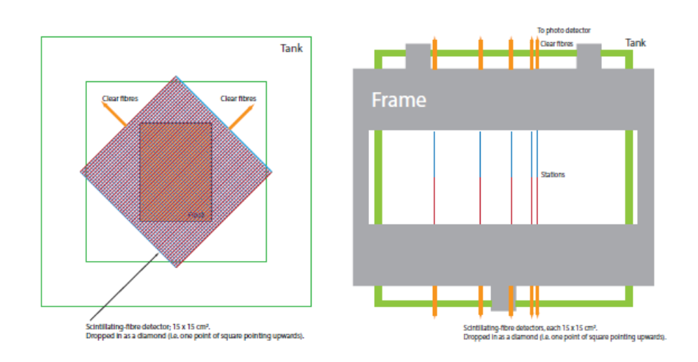
Fig.1 Arrangement of the SmartPhantom
The detection elements of the SmartPhantom are based on 250 micron diameter polystyrene scintillating fibres. Each fibre station consist of 2 planes of fibres, in which the fibre directions are orthogonal. A beam’s-eye view is shown in Fig.1 (left), showing how the 2 orthogonal planes of fibres cover the area to be irradiated. The outer green rectangle represents the water tank, the inner green rectangle the maximum beam size. The central shaded area covers the largest size sample flask for irradiations. A diagram of the assembled phantom from above is shown in Fig.1 (right), in which the 5 fibre stations are shown, mounted on a support frame (shown in grey) and inserted from above into the water tank (green rectangle). The beam is incident from the left in this view.
Fig.2 Photograph of the SmartPhantom prototype
Fig.2 shows a photograph of the partially assembled SmartPhantom prototype, showing the holders for the flasks to be irradiated. In this picture, the beam would be incident from the top.
The scintillating fibres will be spliced to clear light-guide fibres to carry the scintillation light to detectors, housed at a suitable location behind the phantom. The clear fibres may then be coupled individually to photodiodes, or grouped and viewed by an area CMOS camera. The design of the SmartPhantom will be guided by simulations in GEANT4, tracking incident protons from the beamline through the phantom. The results on the simulations will be used to develop analysis scripts, to fit the data and find the position of the Bragg peak. This will then be used to calculate the beam profile, LET and dose delivered in real time. The key emphasis in the application of the SmartPhantom is to be able to derive these parameters from measurements taken shot by shot, as opposed to being derived purely from Monte Carlo simulations.
The authors are actively collaborating with the Technical University of Vienna, with the aim of testing the first prototypes of the SmartPhantom at MedAustron, the Austrian national facility for research into proton and carbon-ion radiotherapy.
Note that other approaches to this include proton tomography, as researched by the PRaVDA collaboration, who have built a prototype silicon tracker for proton tomography: http://www.pravda.uk.com/index.php/78-pgeneral/71-phone. See also Burker et al. (Vienna Conference on Instrumentation 2019) – developing a similar detector system to PRaVDA, in this case for ion tomography.
In proton radiotherapy, secondary neutrons from the proton interaction lead to unwanted dose in healthy tissue. Gioscio et al. ( Vienna 2019) have built a prototype 250 micron scintillating plastic fibre tracker with a SPAD array (from LFoundry).
3.6.4 Beam diagnostics for the low energy beam
SciWire
Beam position and size measurements are necessary at the first ends station. For the Stage 1 beam, the maximum energy of the protons depends on the power of the laser and is therefore directly related to the cost of the laser system. A compromise solution has been proposed, which allows irradiation of cell layers grown on the bottom of standard plastic culture containers. The base of such a container is 1.15mm thick polystyrene. Simulations have been performed of a system in which the proton beam emerges vertically upwards into the Stage 1 end station, through a 75um mylar vacuum window. The window is separated from the underside of the cell culture containers by a 5mm air gap. This arrangement allows for the cells to be irradiated at the Bragg peak of the incident beam. It is essential to have a means of characterising the beam at the end station. While Gafchromic film is capable of providing integrated beam dosimetry, a shot-by-shot characterisation using a very thin detector with a fast response is needed. A device known as SciWire has been proposed [REF_SciWire], in which 2 planes of 250um square-section scintillating optical fibres, with the fibre directions in the two planes orthogonal to each other, are mounted immediately on the air side of the mylar window. This arrangement is shown in Fig.3.
In Fig. 3, the left hand figure shows the physical layout of the end station, with the beam passing through the SciWire monitor and impinging on the base of the cell culture container. The right hand figure shows the positions of the beam Bragg peak, for 3 different energies, namely 10 MeV, 12 MeV and 15 MeV. A beam energy of at least 12 MeV is necessary to be able to position the Bragg peak close to the cell layer, although somewhat higher energies may be accommodated by adding extra material. The Stage 1 design of LhARA is aimed at a 15 MeV beam as a compromise between cost and an immediately useable beam. This may allow more than a single SciWire plane. The SciWire concept has received initial proof-of-concept funding from STFC via an Impact Acceleration Account grant and will be developed further as resources allow.

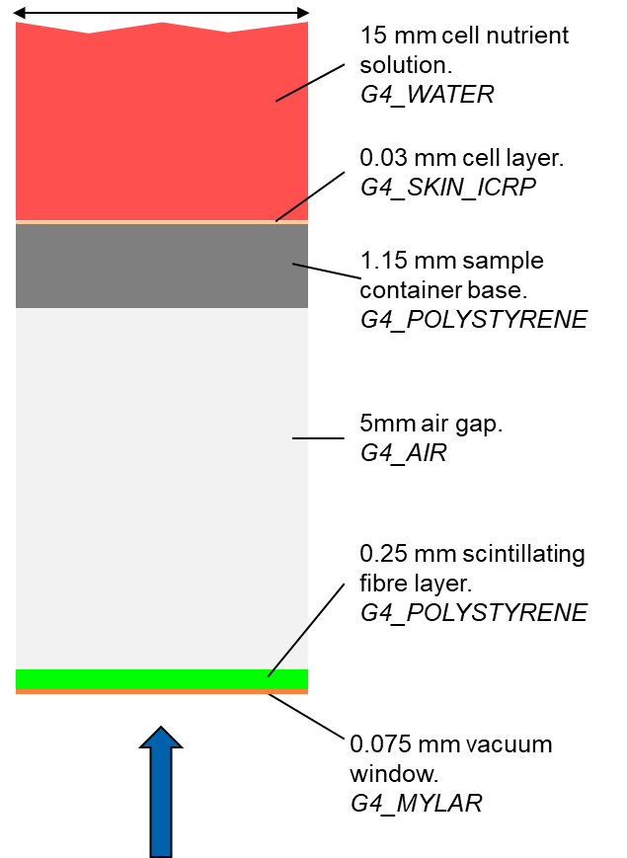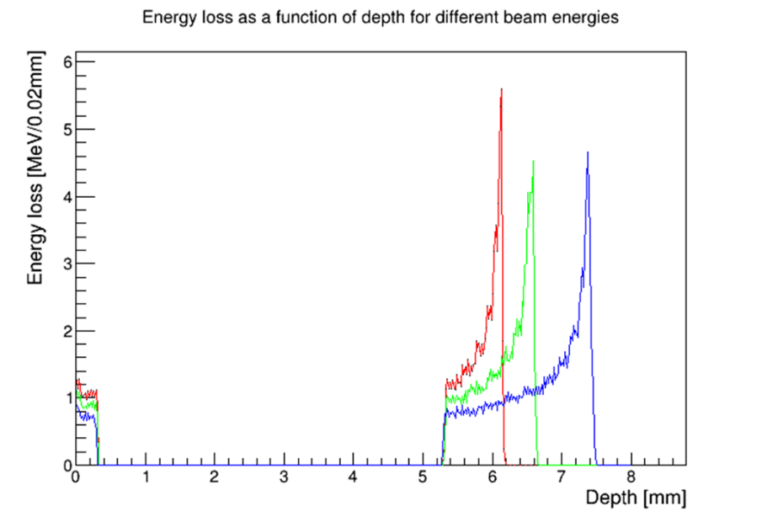
Fig.3 SciWire arrangement for the low energy beam

Detection of the light from SciWire fibres may be by CMOS camera, or using photodiodes. If the instrumentation is sufficiently fast, it could be used to derive feedback signals for the beamline steering.
An additional technology which might be evaluated is the use of monitors consisting of metal electrodes on very thin ceramic substrates, as reported in [REF_AlexHoward] and manufactured in industry: http://www.silson.com/
3.6.5 Beam diagnostics for the high energy beam
For the FFA and associated beamlines, existing facilities will be used as examples.
The proton therapy facility at PSI [PSI_REF] uses a 250 MeV cyclotron, followed by transfer lines to the treatment rooms. The extracted beam from the cyclotron is reduced to the desired energy by a carbon wedge degrader, which is tuned in real time to give the desired depth of the Bragg peak in tissue. Space for instrumentation in a cyclotron is very limited, and the RF fields inside the machine are problematic. One probe is available, inserted radially and with 2 interchangeable heads. One head measures total beam current and the other used a scintillating screen and CCD camera to look at the beam profile and position. A kicker magnet is provided to dump the beam if requested by the patient safety system (PaSS). For initial setup of the cyclotron [PSI_cyclotron_REF], test foils were placed in the beam. This requires breaking the vacuum but can still be useful for initial alignment.
Beam current and profile are measured by ionisation chambers on the beamlines. These exist in different types, with full-area electrodes being used as a beam current measuring device and segmented electrodes being used to measure the profile. If an ionisation chamber is sufficiently low mass and the beam energy high enough, then it can be left in the beam permanently. Thicker chambers are mounted on pneumatic actuators so they can be withdrawn from the beam when not in use. Indeed, the movable chambers at PSI are made deliberately thick enough to cause enough disruption to the beam current, so that the PaSS system is triggered if a monitor is inadvertently left in the beam as treatment commences. If a monitor is to be in the beam permanently, it is best to place it at a point where the transverse beam size is small and the dispersion is large, to minimise the effects of scattering. Insertable monitors are separated from the vacuum by 35 micron thick Ti windows. The Position and Halo Monitor is an ionisation chamber with an open bore, which is mounted in a modified vacuum bellows such that it intercepts the beam halo, to provide a measurement of beam position and transverse dimensions. Halo monitors should be placed where the beam size is large.
For very high beam currents, ionisation chambers may saturate and so secondary emission monitors (SEM) are used. These are made from thin parallel wires placed in the beam and the secondary emission current induced in the wires gives a beam profile. Beam position can be measured if 2 orthogonal planes of wires are used. At the PSI facility, a SEM is placed at the output of the cyclotron to monitor the beam injected into the beamlines.
A destructive measurement of beam profile can be made using a fluorescent screen, viewed by a video camera positioned so as to be protected from radiation damage. Once again the screen is mounted on an actuator so it can be withdrawn when not in use.
Beam loss monitors are usually placed downstream of bending magnets to detect beam instabilities and trigger the PaSS system in case of problems.
In the straight sections multi-layer Faraday cups (MLFC) are provided, which can be inserted into the beam as a destructive measurement. A Faraday cup gives an absolute beam current measurement and a MLFC gives, in addition, the position of the Bragg peak (in copper). This can then be used to predict the position of the Bragg peak (in water) at the output of the beamline, or correlated with measurements on a water phantom. The MLFCs at PSI are made from sheets of copper 0.1mm or 0.2mm thick, separated by 75 micron Kapton insulators.
DAQ needs to be able to store calibration data etc. and apply corrections in real time. It is necessary to be able to find the beam centre from a profile, even when the profile may be non-Gaussian and possibly asymmetric. Custom electronics with wide dynamic range is used where needed and FPGAs can be used to perform fast fitting and pattern recognition of beam profiles.
In the prototype FFA EMMA at Daresbury Laboratory [EMMA_REF], the bunch executes up to 10 turns during acceleration with a spiral path that sweeps out half the pickup aperture (48mm diameter). For accelerator tune measurements, a beam may be circulated continuously, at constant energy. EMMA is made up of 42 F-D cells, equipped with a total of 81 BPMs. A BPM consists of a button electrode pickup, 2 front end modules close to the beamline and a VME module containing the ADCs. In the VME module, memory to store the pickup data for up to 4000 turns is provided.
Research towards a US neutrino factory is geared towards a FFA [USNF_REF] and in this case the instrumentation proposed is based on a system with one high-resolution 4-button BPM per quadrupole magnet. There are in addition 20 straight sections where beamline instruments can be added and the instruments planned are: optical transition radiation (OTR) foils, phase probes for beam-RF comparison, a wall-current monitor and wire scanners. The extraction line will be equipped with a dispersive region for momentum measurement, a “pepper-pot” emittance monitor and a transverse deflection cavity with fluorescent screen for bunch shape measurements. An integrating current toroid or a Faraday cup will provide beam charge measurements.
A suite of instruments for LhARA might include a system of button BPMs to give position information throughout both Stage1 and Stage2 beamlines. Where these would be fitted and the geometry of the pickup blocks needs to be the subject of study and coordination with the accelerator designers. Beam profiles could be measured by SEM grids on both Stage1 and Stage2 beamlines but these should be on pneumatic actuators for at least the Stage1 part, to avoid scattering. Both Stage1 and Stage2 beamlines might be fitted with MLFCs for a definitive measurement of beam current and the Bragg peak position (in copper). The MLFCs are a destructive measurement so would be mounted on pneumatic actuators, but backed up with integrating current transformers for normal running.
3.6.6 Fast feedback controls and monitoring
Taking again the example of the PROSCAN facility at PSI [PSI_electronics_REF], the analogue signals from the beam instruments need to be digitised and fed back to the machine control system (MCS). For example, the BPM currents (current signals from ionisation chambers here) are fed to a LogIV unit, which contains a logarithmic transimpedance amplifier and ADC. The LogIV unit then outputs digitised signals which are accessible via the VME backplane. The digitised signals are read by a VPC digital back end electronics module, which contains 2 FPGAs. The System FPGA runs the firmware common to all VPC applications, such as the high speed VMEbus interface to the MCS. The User FPGA runs the firmware which implements the local storage and processing algorithms. RAM is provided to store lookup tables (for example for linearising pickup signals) and instrument waveforms for readout via the MCS. The User FPGA is used to calculate quantities derived from raw pickup data, such as total beam current, beam vertical position, beam horizontal position, beam sizes, etc. Limits can be set on parameters which can be used in an interlock system, via fast optical data links. BPM data is sampled at 5kHz and fed back to the MCS for applying beam corrections.
3.6.7 Technical challenges and R&D programme
- General
Review the instrumentation needs of the facility outlined here with input from beam instrumentation experts, beam controls experts and the accelerator designers to ensure the solutions eventually chosen are optimal. Understand fully where off-the-shelf solutions can be used and where custom solutions are needed. Preference should be given to COTS solutions wherever practical.

(Suggest 0.25 applied physicist working on this for a year to develop specs.)

- Dosimetry with films/track detectors
Measurement and characterisation of nonlinear response at high dose rates as proposed by NPL.

- SmartPhantom
The SmartPhantom needs to be developed from its current early prototype state to a completed instrument. Current estimates are £180K hardware and £60K labour. (I don’t understand the cost estimates in the reference).

- Sciwire
Requires development of the concept into a practical design. Some of it overlaps with SmartPhantom.

- Thin ceramic monitors
Requires further evaluation and development as a possible alternative (or complementary) means of beam measurement to the SciWire. Possibly it could be used in a SEM mode in which case Ti electrodes could be tried (apparently secondary emission coeff. is more reproducible in Ti than alternatives).

(Suggest SmartPhantom + Sciwire + ceramic monitors approximates a 3 year postdoc if some engineer/technician support is also available, at the level of at least 0.2 engineer and 0.3 technician).

- BPM system
Development of suitable pickup geometries for lhARA beamlines. There are companies with experience in this so probably a matter of defining specifications. Electronics is available from industry (e.g. Bergoz BB-BPM at EU 14K to instrument a typical 4-button pickup).

- Other beam instrumentation
SEM grids for Stage1 and Stage2 or other beam profile measurement. How many sample points TBD with accelerator designers. Probably need to be retractable, particularly in Stage1.
Integrating current transformer (e.g. Bergoz Turbo-ICT at EU 38K). One for Stage1 beamline, one for Stage 2 beamline.
MLFCs: one for Stage1 beamline, one for Stage 2 beamline.

Also consider: bunch length measurement, pepper-pot emittance monitors. Halo monitors are interesting and I wonder if a (thick) halo monitor with the capability of measuring halo particle energy might eventually give enough information to calculate the downstream dose.

Yap et al. working on a halo monitor based on LHC-B Velo detector. This looks to me unneccesarily expensive and needs some layers of heavy material to get energy by dE/dx (or stopping).

- Controls
Presume that the beam instrumentation is run under EPICS software to integrate with the accelerator controls. In the talk in [REF_AlexHoward] the CMS SERENITY DAQ is outlined. As far as I can tell this has much the same functionality as the PROSCAN facility DAQ so it should be evaluated further.

3.6.8 References
[REF_Brenner] C.Brenner & J.Green, Ion diagnostics for laser-driven ion beam experiments at CLF, Low energy ion beam diagnostics workshop, Imperial College (2019)
[REF_Ettlinger] Oliver Ettlinger, private communication
[REF_CR39] Fews, A.P. et al, High resolution alpha particle spectroscopy using CR39 plastic track detector. Nuclear Instruments and Methods, 1982. 197: p. 517-529.
[REF_FNTDs] Greilich, S., J.M. Osinga, M. Niklas, F.M. Lauer, F. Bestvater, and O. Jakel, Quantitative read-out of Al2O3:C,Mg-based fluorescent nuclear track detectors using a commercial confocal microscope. 2014
[REFS_from_Schettino] [1] A. Piermattei, et al, Med. Phys., 27, 1655 (2000), [2] D. Kirby et al, Phys. Med. Biol. 55, 417 (2010), [3] F. Fiorini et al, Phys. Med. , 30, 454 (2014)
[REF_SmartPhantom] Barber et al., Outline design and cost estimate for the SmartPhantom, Unpublished note ?? (Oct. 2018)
[REF_SciWire] A.Kurup, Diagnostics for LhARA, CCAP Diagnostics Workshop (2019)
[PSI_REF] R.Doelling, Diagnostics of the PROSCAN proton therapy beamlines DIPAC, Mainz (2003)
[PSI_cyclotron_REF] A.E.Geisler et al., Commissioning of the ACCEL 250MeV proton cyclotron, 18th International Conference on Cyclotrons and their Applications (2007)
[EMMA_REF] A.Kalinin et al., Diagnostic system commissioning of the EMMA NS-FFAG facility at Daresbury Laboratory, IPAC 10, Kyoto (2010)
[USNF_REF] S. Koscielniak et al., Electron model of linear-field FFAG, PAC ’05 Knoxville (2005)

