Pressure drop across an orifice in vacuum

Consider 2 vacuum systems

Vac system 1 – laser side.

- Assume 300l/sec pump – matched by gas load – zero net pumping
- Base pressure of 1e-5 mBar = P₁

Vac system 2 – Gabor lens side

- 300l/sec pump = S₂
- Vac system 2 has lower gas load (due to construction materials, processing and in vacuum components/systems) and therefore lower base pressure

Pressures are in molecular flow regime.

Vacuum systems connected by an 4mm diameter ‘pipe’ 50mm long tapering up with 2 degree included angle. Exit diameter = 4+2*(50tan1) = 5.74mm.

Short tube – Dushman tables

Dushman tables gives value for the conductance of round straight tubes. Dushman figures are calculated and are known to deviate from measurement by up to 20% but are sufficiently accurate for this task. 0.2cm radius round tube with length to radius ratio (l/a) = 25 C_{t}=0.178 l/s

Alternate conductance calculation method:
Long round pipe approximation: C_{t}= 12.1d^3/l C_{t}= 0.194 l/s.

Throughputs (Q) measured at either end of tube are equal (no gas generation inside tube)

Q₁=p₁S₁=p₂S₂= C_{t} (p₁-p₂)=Q₂ p2=p1 C_{t} /(S₂+ C_{t})

C= 0.018 p₂=p₁*6e-4 C=0.02 p₂=p₁*4e-4

Pressure on low pressure side will be between 3 and 4 orders of magnitude down on pressure on high side.
Tube will provide more than 3 orders of magnitude pressure drop.

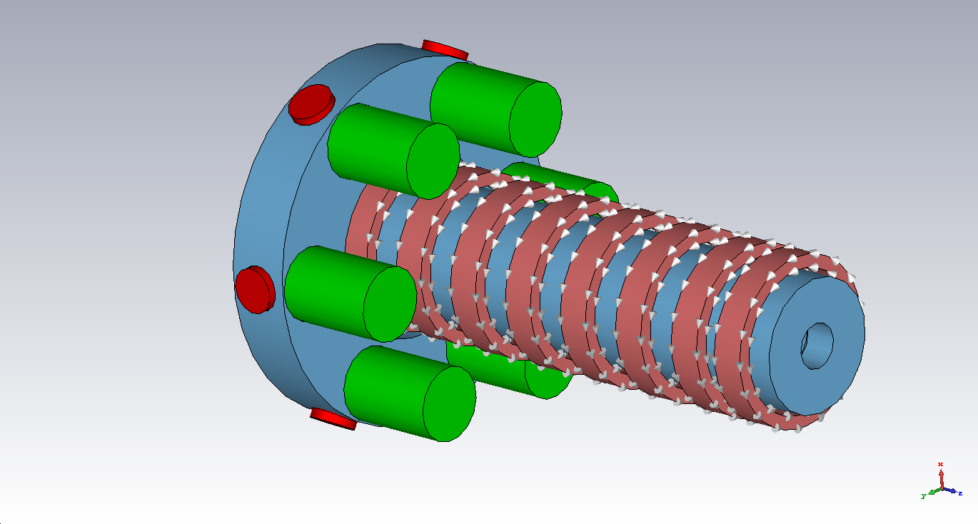

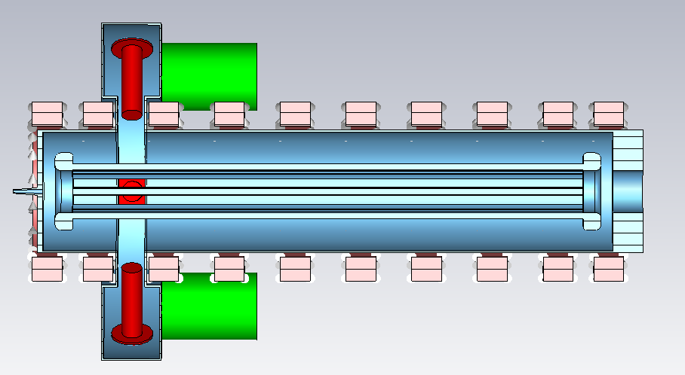

- 10 coils, ~15V 10A, 150W/coil, for 300W total, 7kg per coil – possible to reduce weight at cost in power.
- Coils will run at this level with no active cooling
- Coil nearest to target is run in reverse direction to ‘shape’ magnetic field lines. Objective is to arrange magnetic field lines perpendicular to anode-cathode gap to provide some magnetic insulation and resist breakdown.
- 2nd to end coil requires higher current – will need more volume of conductor to reduce power.
- Current arrangement is not ideal, optimisation may offer some improvement.
- Alternatives – could locally increase B field at ends – similar improvements to B field profile – also offer particle containment by magnetic ‘bottle’
- Pumping by small turbo pumps – pump port will throttle larger pumps at annular gap – distributed pumping is almost always better
- Supplementary pumping by NEG pumps – once system reaches 1e⁻⁷mBar possible to close off turbos and use only NEG pumps.
- Only one pump port to allow magnetic coils to slide into place.
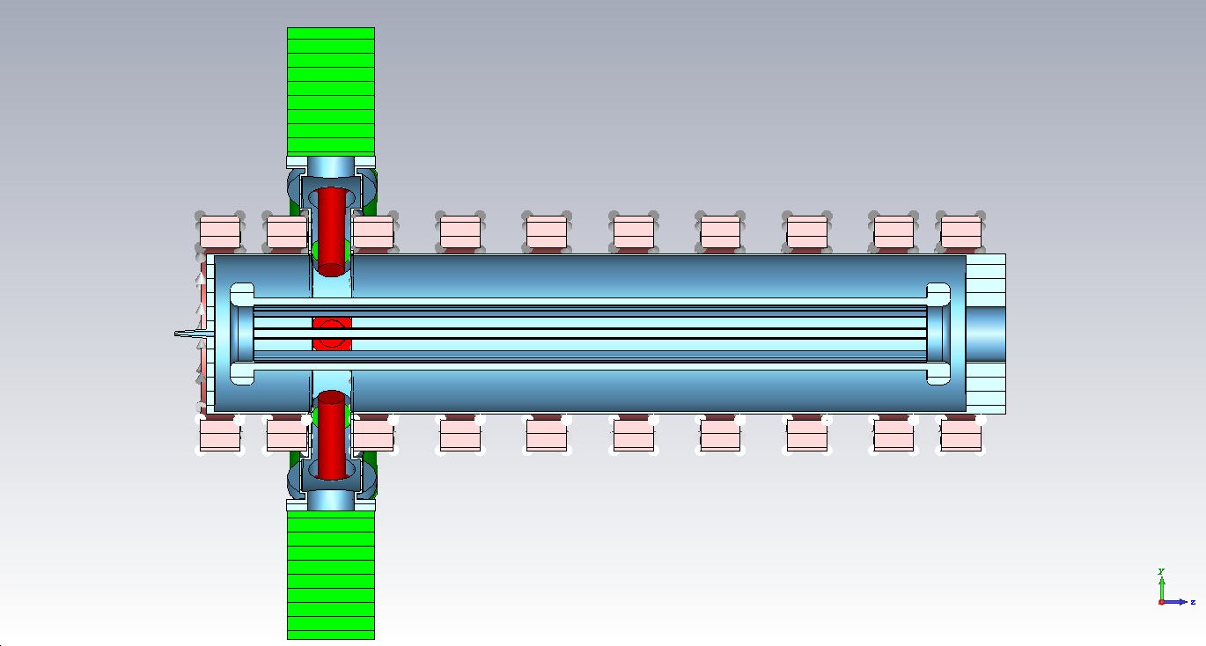
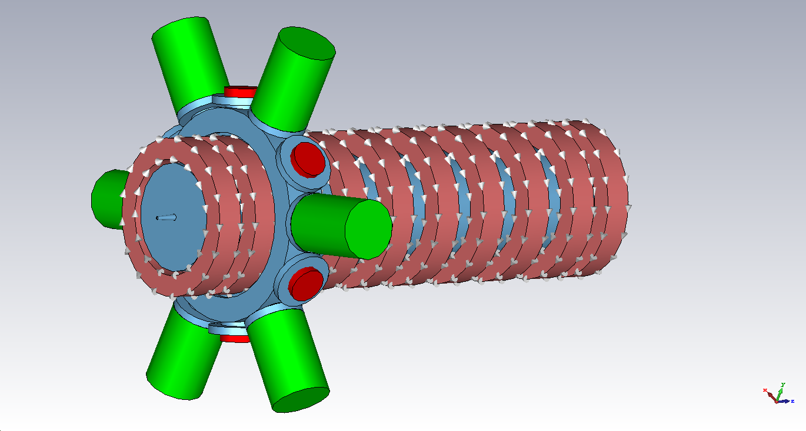
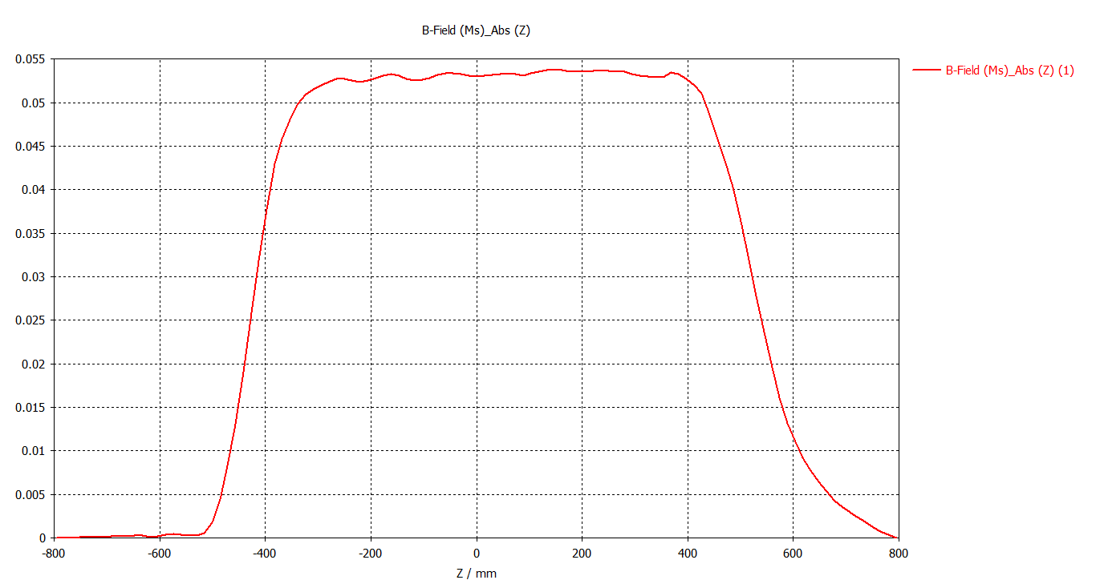

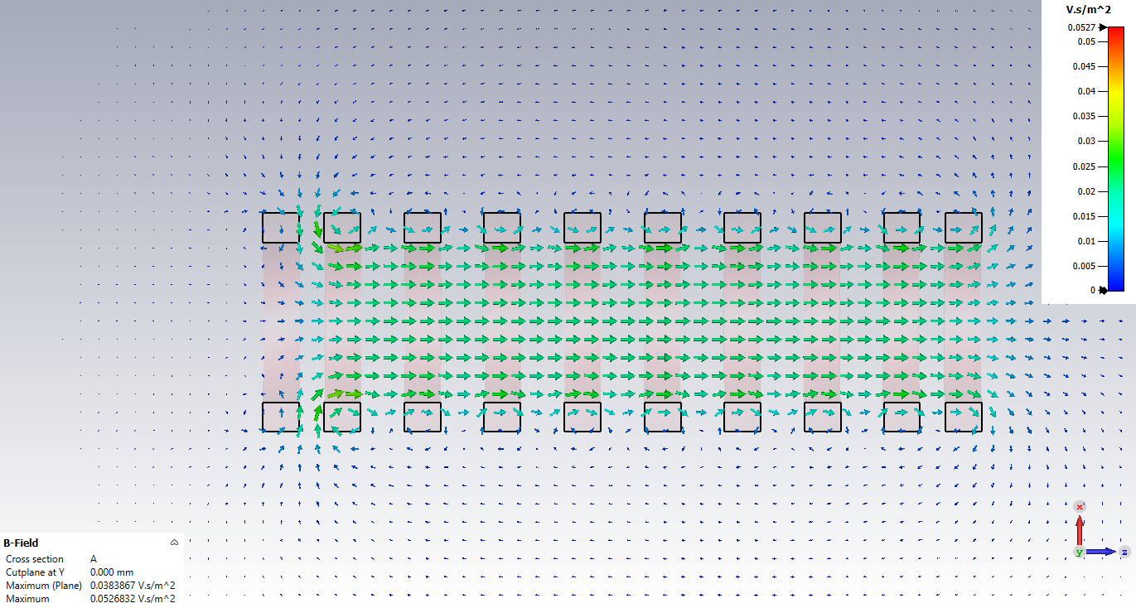

- Hollow anode – field relieving electrodes facing cathodes.
- Sectional ‘cylinder’ to allow vacuum pumping. Field relieving to anode ‘bars’ required to manage radial E field enhancement.
- Possible electron injection between ‘bars’
- Not suitable for electron density measurement by RF (only possible for e density at 10¹⁷/m³)
