In vitro end-station floor plan and equipment

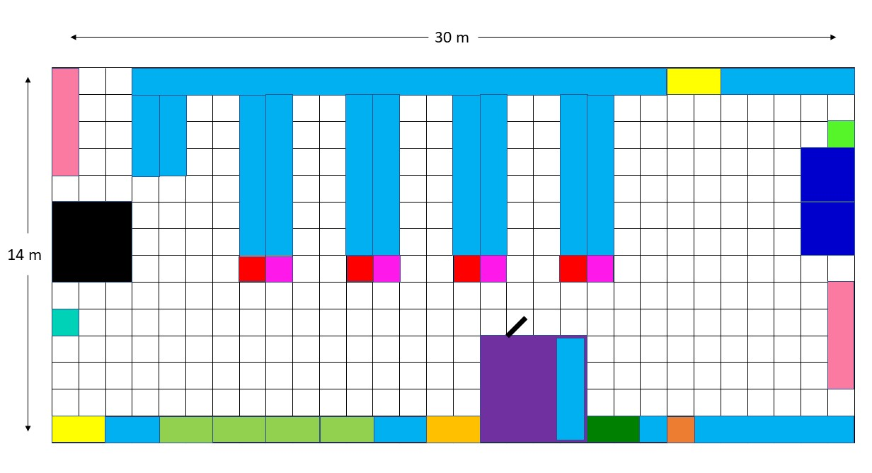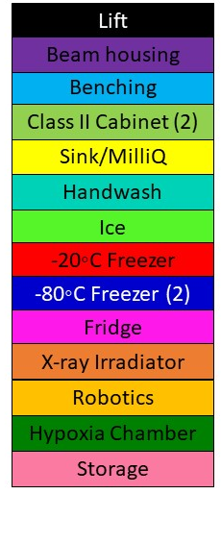
List of equipment (+possible manufacturers/prices)
- Refrigerated centrifuge (x2) - Eppendorf 5804R – £12,000
- Refrigerated ultracentrifuge - Beckman Coulter Optima MAX-XP – £50,000
- Hypoxia chamber - Baker InvivO₂/Don Whitley – £40,000
- Ice Flaker machine - Scotsman AF80 – £2,500
- CellRad x-ray irradiator - Faxitron – £70,000
- Class II cell culture cabinet (x4) - Esco Airstream – £28,000
- Digital microscope - Invitrogen EVOS M5000 – £20,000
- Light microscopes (x3) - Nikon Eclipse TS100 – £9,000
- CO₂ cell incubator (x2) - Panasonic – £14,000
- Fridges/-20°C Freezers (4 each) – £2,000
- -80°C Freezers (x2) - Panasonic – £20,000
- MilliQ water - Avidity 60L – £6,000
- Colony counter - Oxford Optronix GelCount – £25,000
- Fluorescence microscope/Live cell imaging - ?
- Robotic workstation – Tecan/Beckman – £200,000

